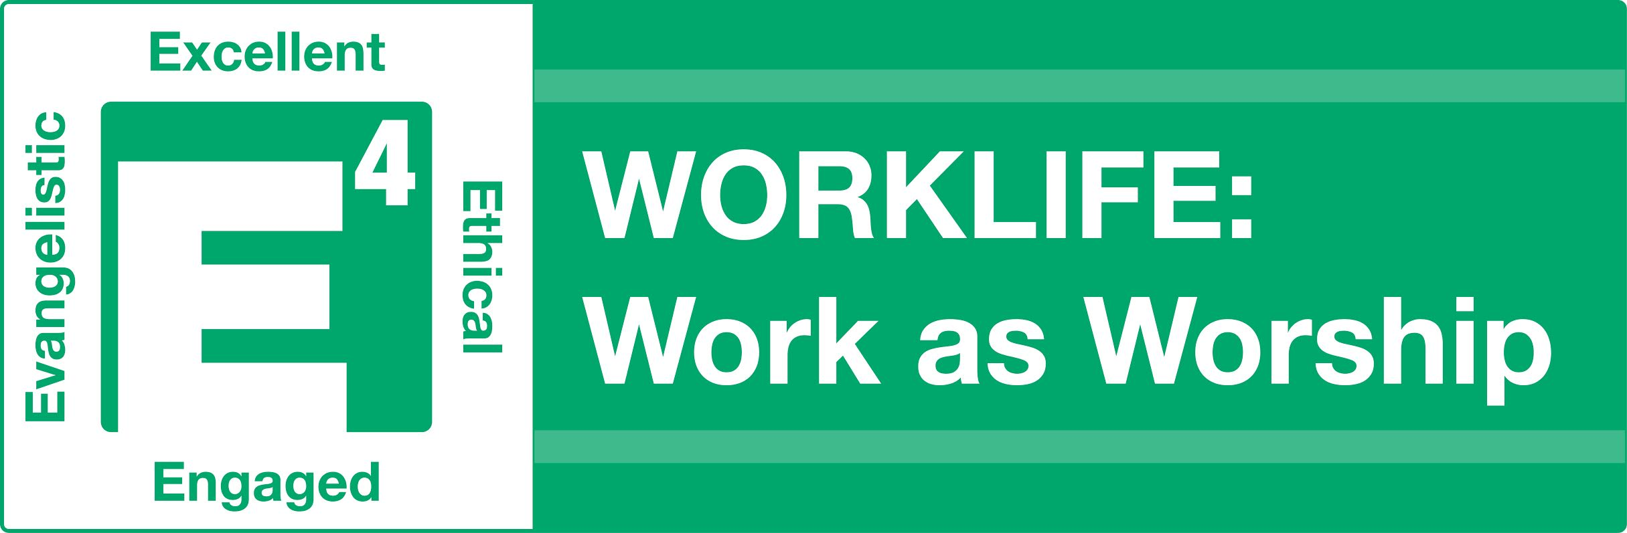

As you listen to each podcast, there are a few things we want you to keep in mind:
- We define “WORKLIFE” or “work life” as: your current job search and then future employment, your current job/employer, or if retired, your current activities.
- Prior to each brown bag lunch, you should listen to two podcasts and complete the listening guide for each. We will use the discussion questions for our time together.
- When the speaker, Pastor Tim Hawks, the Lead Pastor of Hill Country Bible Church Austin since 1989, refers to the WORKLIFE Challenges, we have included them below. You only need to do one. We have added some wording from what Pastor Tim reads to make it applicable if you are currently unemployed. Pastor Tim received his bachelor’s degree from Baptist Bible College in Springfield, MO, and a master’s degree from Dallas Theological Seminary.
- Pastor Tim also refers to a blog, affinity groups and a WORKLIFE website. Instead of those resources, you will be sharing with each other in our discussions to hear great stories, you will be in a small group each session, and we will also be giving you some tools each week.

Session 2 Listening Guide
Podcast 3 - “Economics or Ethics” Daniel 3:1-30
What happens when the cost of doing business is _______________? You should never feel like you have to give up your values in order to keep your job.
Examples of ways that people sacrifice their ethics.
1) Promising more than what we or the company could deliver.
2.) Committing to a deadline that I have no intention of keeping.
3.) Signing something that’s inappropriate or illegal.
4.) Fixing an expense report or a bill of sale to ask for more than what was agreed on.

Rationalization:
- __________ standing- “If I were to play fair, I wouldn’t be able to live in this neighborhood, etc."
- ______ of position- "I’ll play the game because I want to keep this manager position."

- Effort ___________- “I’ve worked too hard to get to the place where I’m at, and the thought of going backwards over ethics…"
Reality:
- Loss of _________________
- Loss of _______________
- Loss of ____________________
Questions:
- Do I serve a God who is ______? Do I serve a God who is able to oversee the outcome of my life, or do I need to compromise along the way to ensure that the others who I believe control my life are pleased with me? You know, if you’re afraid that the people who control the economy in your life, if you’re afraid that they are sovereign over you, and that makes you someone who violates your ethics and order to obey, then you know what? You’re really a slave. You’re a slave to your fear of what might happen to you.
- Do I conduct my work life in a ______________? If you choose to follow the ethics of Christ in your work place, you give God the opportunity to enter in and intervene in powerful and amazing ways.
APPLICATION: Take the WORKLIFE Challenge (Pastor Tim refers these in the podcast.)
#1: Were you “fudging” in any area of your work life (past or present) or job search (e.g. fudging numbers or time, not telling the whole story, exaggerating your progress on a project)? How about in your job search in the way you answer interview questions or something on your resume? Commit to and follow through on a specific plan of action. Make restitution and seek forgiveness if applicable.
#2: Pray and ask God to reveal your real motivation in your work life. Is glorifying God a primary motivator for you, or are you driven by the desire for promotion, financial gain, prestige or other reason? Write out a prayer to God expressing your desire to be motivated by your love for Him and that your work would bring Him honor.
But even if He does not, we want you to know, O king, that we will not serve your gods or worship the image of gold you have set up. Daniel 3:18
Podcast 4 – “Where Ethics and Authority Meet” Col. 3:22 – 4:1
An Ethical Worker: Recognizes and ________ to ____________.
My Actions: You listen and you’re characterized by doing it and doing it well.
My Attitude: Characterized not by self-serving work but by loyal work. Not just when the boss is looking, or not just when somebody’s paying attention, or not when it benefits you, and not just on the projects that get high profile.
We’re ultimately serving the person that is our boss or giving us direction, and we’re serving that person as if we’re serving the Lord. In fact, these verses in Colossians say that it’s really Jesus Christ that we’re serving.
My Accountability:
An Ethical Boss: Respects the _________________ and understands that people have ______.
What is my ________? You will leave behind two very clear indicators of how well you did. The first indicator is task, the performance or accomplishment side of your job. The second indicator is the people side. Did people grow, enjoy themselves and were enriched and blessed in the process?
Who grades my ____________?
Apply it to your work life:
- Determine your _________ and ___________ authority. Who do you work for specifically?
- Examine your general _________ toward your work and authority.
Commit to seeking ______________ in your work life.

APPLICATION: Take the WORKLIFE Challenge

#1: Think about ways you may have demonstrated a bad attitude in your work life (previous job and current job search). Have you engaged in gossip, cast others in a poor light, or contributed to low morale by not supporting those in authority? Commit to follow through on a specific plan of action, make restitution and seek forgiveness, as applicable. If job searching, come up with a plan to avoid this in the future.
#2: Regardless of our work life role, we are all ultimately under God’s authority. Do you relate and respond to God as though He really has the final say in your life? In what ways do you demonstrate your submission to His leadership? Ask God to show you areas where you have resisted or challenged Him, especially in your work life or job search.
Slaves, obey your earthly masters in everything; and do it, not only when their eye is on you and to win their favor, but with sincerity of heart and reverence for the Lord. Col. 3:22

Session 2 Discussion Questions
Icebreaker: Describe the best and worst boss you ever had.

From Podcast 3 - “Economics or Ethics”
- Do you believe that it is possible for a Christian to live out the ethics of Christ in today’s world? What are some of the challenges?

- Have you ever been asked to compromise your convictions in your work life? How did that come about and what did you do?

- Do you ever struggle with rationalizing your behavior based on:
  - Economic standing
  - Ego of position
  - Effort sacrificed
What would happen to you right now if you lost any of the above? If out of work, how are these issues impacting your decision-making and attitude?

- Give an example of a time when you trusted God and saw Him show up in an amazing way.

Podcast 4 – “Where Ethics and Authority Meet”
- Read Colossians 3:22. Interject the word “worker” for “slave” and “boss” for “master.” How does this verse hit you? What do you face or have you faced in your current work life that makes this verse difficult to apply?

- Have you ever displayed a “bad attitude” in a work context? What was the reason and what became of it?

- Pastor Tim talked about our “wake.” What is a wake? What are both sides of the wake important in a work context? In your current work life or job search, how would you describe your wake?

- Who do you work for? How is your relationship going? What Divine help you need to make it better?

