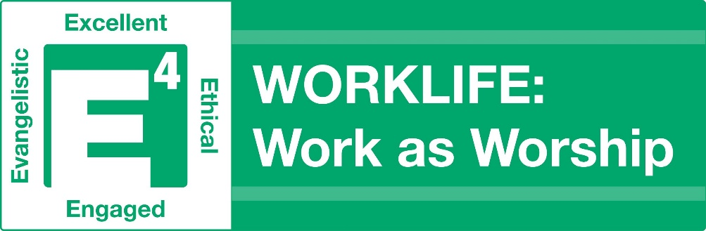
SELF-STUDY GUIDE
Thank you for your interest in learning about Work as Worship. This self-study guide will guide you through the materials available on the website.
If you have questions as you go through the study, please email us at info@job-seekers-network.org.
The self-study can easily be broken into 6 or more different units and can be used as your devotional/Bible study time with God.
While you won’t have the built-in discussion group from our live program, we encourage you discuss it with others. Better yet, have others join you in going through the self-study materials and discuss it together (e.g., a small group from church, a good friend or co-worker)!

Session I (Podcasts 1 & 2)
Unit 1:
“Takin Care of Business” – Read the transcript or listen to the podcast.
Review the E4 Session 1 Listening Guide for Podcast 1 as you listen/read.
Go over the Discussion Questions for Podcast 1 and think of your answers.
Choose a WORKLIFE Challenge for your personal application.
Unit 2:
“Why Dell and Jesus Should Be Friends” – Read the transcript or listen to the podcast.
Review the E4 Session 1 Listening Guide for Podcast 2 as you listen/read.
Go over the Discussion Questions for Podcast 2 and think of your answers.
Choose a WORKLIFE Challenge for your personal application.
From the Additional Resources on the Website, take the E4 Assessment.

Session 2 (Podcasts 3 & 4)
Unit 1:
“Economics or Ethics” – Read the transcript or listen to the podcast.
Review the E4 Session 2 Listening Guide for Podcast 3 as you listen/read.
Go over the Discussion Questions for Podcast 3 and think of your answers.
Choose a WORKLIFE Challenge for your personal application.

Unit 2:
“Where Ethics and Authority Meet” – Read the transcript or listen to the podcast.
Review the E4 Session 2 Listening Guide for Podcast 4 as you listen/read.
Go over the Discussion Questions for Podcast 4 and think of your answers.
Choose a WORKLIFE Challenge for your personal application.
From the Additional Resources on the Website, work on the Plan Document and review the Tool Kit.

Session 3 (Podcasts 5 & 6)
Unit 1:
“Recognize Me?” – Read the transcript or listen to the podcast.
Review the E4 Session 3 Listening Guide for Podcast 5 as you listen/read.
Choose a WORKLIFE Challenge for your personal application.
Go over the Discussion Questions for Podcast 5 and think of your answers.

Unit 2:
“A Day of Good News” – Read the transcript or listen to the podcast.
Review the E4 Session 3 Listening Guide for Podcast 6 as you listen/read.
Go over the Discussion Questions for Podcast 6 and think of your answers.
Choose a WORKLIFE Challenge for your personal application.
From the Additional Resources on the Website, fill out the Impact List. Review the Bridge Illustration exercise from the Tool Kit, introduced last session.
Review the other additional resources for inspiration.
Completed all 6 of these sessions? Congratulations! Email info@job-seekers-network.org to let us know you completed the self-study. We’d love to hear how it went for you and commission you as a Workplace Worshipper!

These materials are provided to you by:
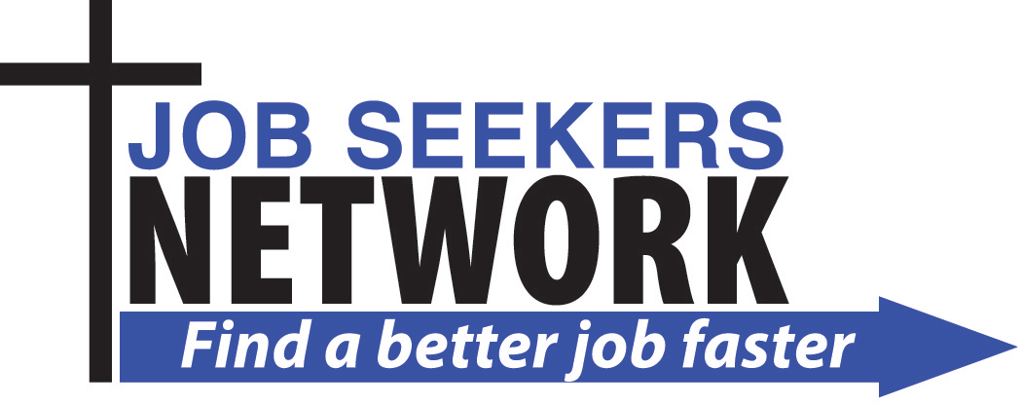
A 501(c)(3) located in Austin, TX
"Top 5 Job Club in the USA"
www.job-seekers-network.org

