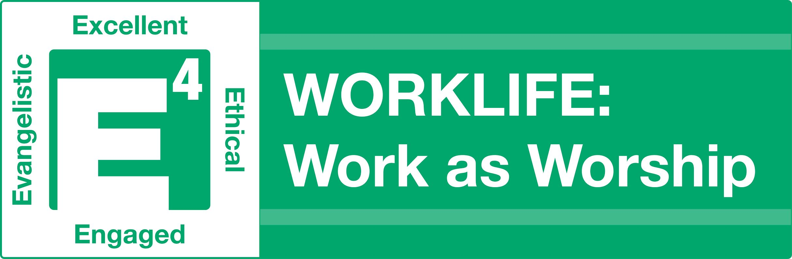TOOL KIT

Work as Worship Specific Resources

Bible:
The Theology of Work Bible Commentary explores what the Bible says about faith and work, book by book through the Bible. https://www.theologyofwork.org/

Books:
-Every Good Endeavor: Connecting Your Work to God's Work by Timothy Keller
-Halftime: Moving from Success to Significance by Bob Buford

Worship God through the 4Es: Excellence, Ethical, Engaging and Evangelistic

EXCELLENT and ETHICAL
(Strong devotional, prayer and Bible study habits are critical to understanding and maintaining these behaviors)
Devotional Life and Prayer:
-7 Minutes with God pamphlet: https://www.usna.edu/Navigators/_files/documents/7minwithgod.pdf
-Tyranny of the Urgent pamphlet:
http://www.olemissxa.org/wp-content/uploads/2014/06/Tyranny-of-the-Urgent.pdf

Books:
-A Praying Life by Paul Miller
-When People Are Big and God is Small Edward Welch

ENGAGING (Relating and Serving)
Spiritual Gifts Inventory based on Romans 12:
https://mintools.com/spiritual-gifts-test.htm

Books:
-The Volunteer Revolution by Bill Hybels
-The Treasure Principle by Randy Alcorn

EVANGELISTIC
Methods & Approaches:

-Bridge Illustration Training Video – https://vimeo.com/120370274 How to transition into and share the Bridge Illustration.

-Three Circles Gospel Illustration – https://www.youtube.com/watch?v=5W8ynRMr59k

-BLESS approach to evangelism (applies to the workplace, too) – https://www.evangelismcoach.org/2016/5-ways-bless-neighbor/

Books:
-God Space by Doug Pollock
-The Art of Neighboring by Pathak and Runyon

Reproducing the 4 E’s in others as a Disciple Maker
Curricula and Approaches in Establishing Spiritual Basics:

-Fully Formed Follower discipleship process developed at Hill Country Bible Church

-Foundations (CRU) – new believer early follow up and discipleship to establish a person’s basic identity in Christ and to begin to follow Christ:
https://www.cru.org/us/en/train-and-grow/help-others-grow/discipleship/adult-discipleship-resources/foundations-study.html

Books:
-Lost Art of Disciple Making by LeRoy Eims
-Intentional Disciplemaking by Ron Bennett
-Master Plan of Evangelism by Robert Coleman

